title of the paper
Name and surname of the author – authors without the academic degrees
Abstract
Text. (15 lines max.)

Key words:
word, word, word. (10 words max.)

Chapter title
Text.

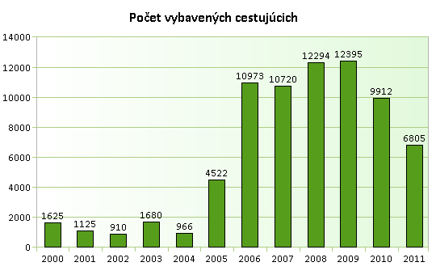
Chart 1 The number of passengers handled at the airport Zilina (2000 – 2011)
Zdroj: Statistics. In: Letisko.sk. [cit. 11.9.2012] Available on: http://www.letisko.sk/statisticke-udaje

Headings 2
Text.

Literature and sources:
SURNAME, N.: Title. Edition. Place of publication : Publisher, year. 00 pp. ISBN.
PRIEZVISKO, M.: Title. [online]. Edition. Place of publication : Publisher, dd. mm. yyyy. [cited yyyy-mm-dd]. ISBN. Available from: http://www.text.com/text2

Contact data:
Name and surname of author incl. the academic degrees
Name of the organization
Address of the organization
ZIP code and city
COUNTRY
E-mail address of the author

De PELSMACKER, P. – GEUENS, M. – Van den BERGH, J.: Marketingová komunikace. Praha : Grada Publishing, 2003, p. 48.

