TITLE OF THE PAPER

Name and surname of the author – authors without the academic degrees
Abstract:
Text. (15 lines max.)

Key words:
word, word, word. (10 words max.)

Chapter title
Text.

Heading 2
Text.

Chart or picture:
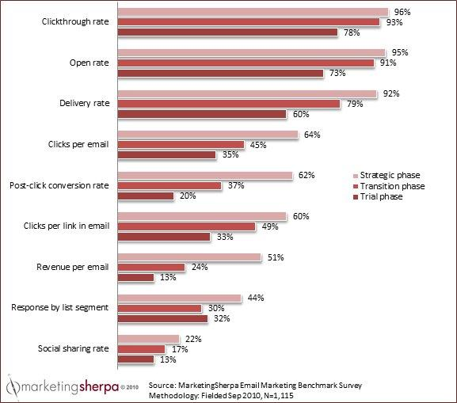
Chart 1 Results of marketing research
Source: KOTLER, P., PFOERTSCH, W.: Marketing. Berlin : Springer, 2006, p. 94.

Table:

Table 1 Old vs. New Marketing
 | The New Marketing |  | OLD MARKETING
It’s about | CUSTOMER | NOT | PRODUCT
It’s about | CONVENIENCE | NOT | PLACE
It’s about | COST | NOT | PRICE
It’s about | COMMUNICATION | NOT | PROMOTION
Source: CLOW, K. E., BAACK, D.: Reklama, propagace a marketingová komunikace.
Brno : Computer Press, 2008, p. 30.

Acknowledgement: (Fill in only if the paper is part of a project.)

Literature and sources:
Full version of citation rules can be found at: http://fmk.sk/veda-a-vyskum/citacne-pravidla/

Contact data:
Name and surname of author incl. the academic degrees
Name of the organization
Address of the organization
ZIP code and city
COUNTRY
E-mail address of the author

